Energy Consumption Prediction
Predicting & Explaining Household Appliance Energy Use (Wh)
A Machine Learning Case Study • EDA → Modelling → SHAP → Business Value
Dataset: UCI / Kaggle Appliances Energy Prediction
19,735 records · 10-minute cadence · Jan–May 2016
Prepared June 2026

Contents

1. Executive Summary
Electricity costs are rising and energy use is uneven across the day. This project builds a machine-learning system that predicts a household's next-interval appliance energy consumption and, just as importantly, explains what drives it — so homeowners, building operators and utilities can shift load to cheaper hours, optimise HVAC, and forecast demand peaks.
Headline result: a tuned LightGBM model explains 57% of the variance in energy use on a held-out future period, with a typical error of about 24 Wh — and SHAP reveals that time-of-day rhythm and recent usage, more than weather, drive this home's consumption.

Key results at a glance
Model | Test R² | RMSE (Wh) | MAE (Wh)
Linear Regression | 0.40 | 70.1 | 28.1
Random Forest | 0.56 | 60.2 | 27.9
XGBoost | 0.56 | 60.1 | 23.6
LightGBM (best) | 0.57 | 59.3 | 23.7

An honest number. Many notebooks claim 80–90% R² on this dataset, but that comes from a random train/test split that leaks the autocorrelated past into the future. This project evaluates on a strict chronological split with lag features that only ever see history — so 0.57 is what you would actually get forecasting truly unseen data. It matches the published benchmark (Candanedo et al., 2017).

2. Business Problem
Homeowners, smart-building operators and utility companies all want to predict future energy consumption, understand what causes high consumption, and act on it to reduce cost and strain on the grid.

Business questions
- What drives appliance energy consumption?
- Can we predict the next interval's energy usage?
- Which environmental and behavioural factors impact energy use most?
- Where can loads be shifted or HVAC tuned to save cost?

Who benefits
Stakeholder | Value delivered
Homeowners | Lower bills via load shifting and smarter HVAC scheduling
Utilities | Demand-peak forecasting for better grid planning, fewer overloads
Building managers | Optimised HVAC schedules, lower operating cost & carbon footprint

3. Dataset Overview
The dataset records a single house over roughly 4.5 months at a perfectly regular 10-minute cadence. It has zero missing values; rv1/rv2 are identical random-noise columns excluded from modelling.
Type | Examples
Target | Appliances energy use (Wh)
Indoor sensors | T1–T9 temperatures across 9 zones
Humidity | RH_1–RH_9 per zone
Outdoor / weather | T_out, Pressure, Wind speed, Visibility, Tdewpoint, RH_out
Time | Date-time → hour, day, month, weekend, night flags

Target is heavily right-skewed (skew ≈ 3.4; median 60 Wh, max 1080 Wh). Most intervals are quiet with occasional consumption bursts — which is why we model log1p(Appliances) and keep the spikes rather than deleting them.

4. Exploratory Data Analysis
Six views answer: how is energy distributed, when is it used, and what is it related to?

4.1 Energy consumption distribution
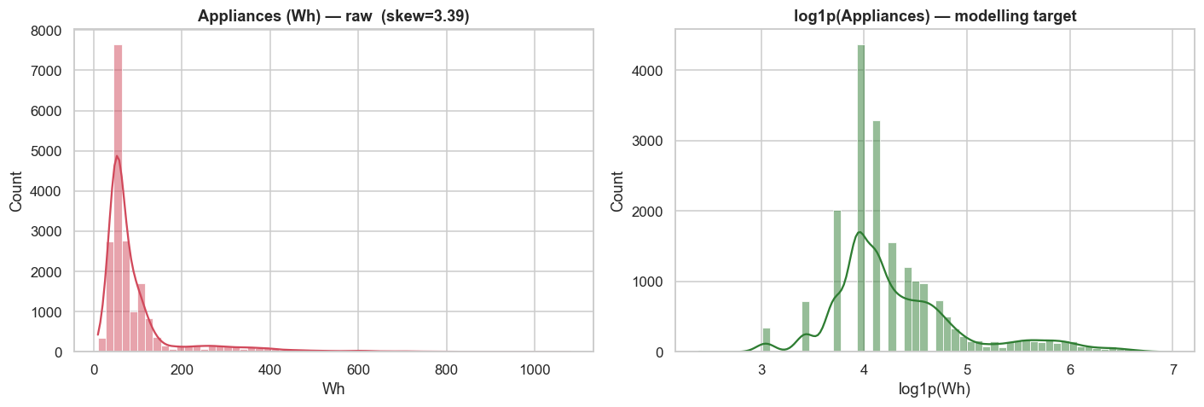
Raw target (left) is sharply right-skewed; log1p transform (right) is near-symmetric — the modelling target.
Insight: a few high-consumption periods dominate the tail. Modelling the log keeps those peaks while stabilising the error.

4.2 Hour of day vs energy
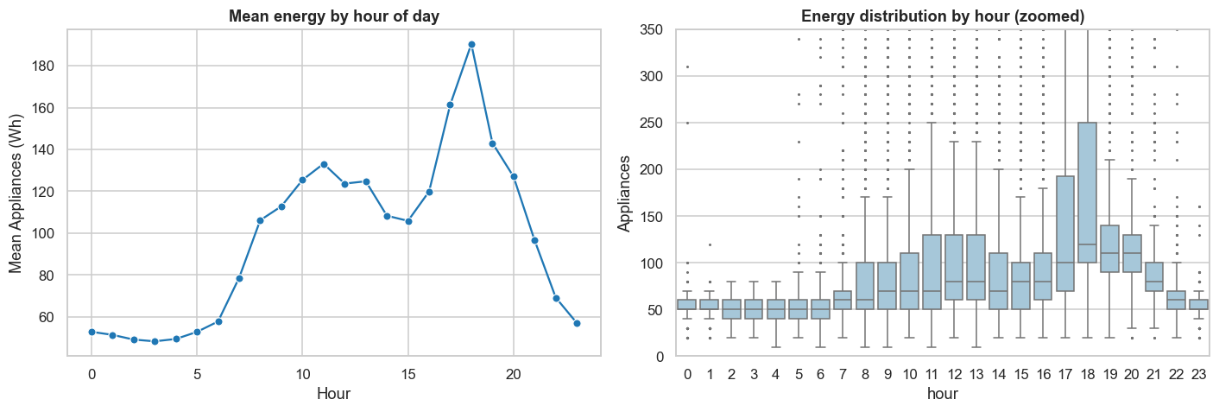
Mean energy by hour (left) and distribution per hour (right).
Insight: usage is lowest overnight, rises through the morning, and peaks in the early evening (~17–20h). This is the prime window for load-shifting recommendations.

4.3 Temperature vs energy (HVAC dependency)
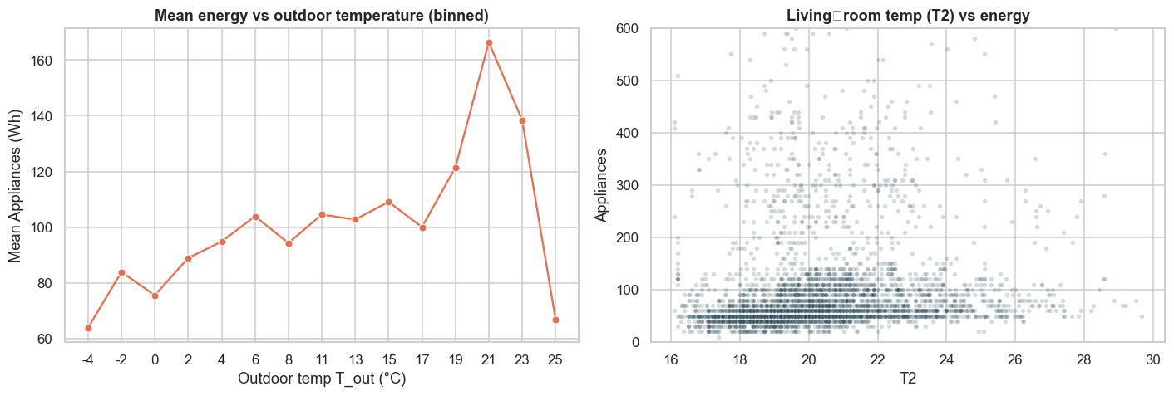
Binned mean energy vs outdoor temperature (left); living-room temperature scatter (right).
Insight: the temperature relationship is real but non-linear — evidence that tree models will outperform linear regression.

4.4 Humidity vs energy
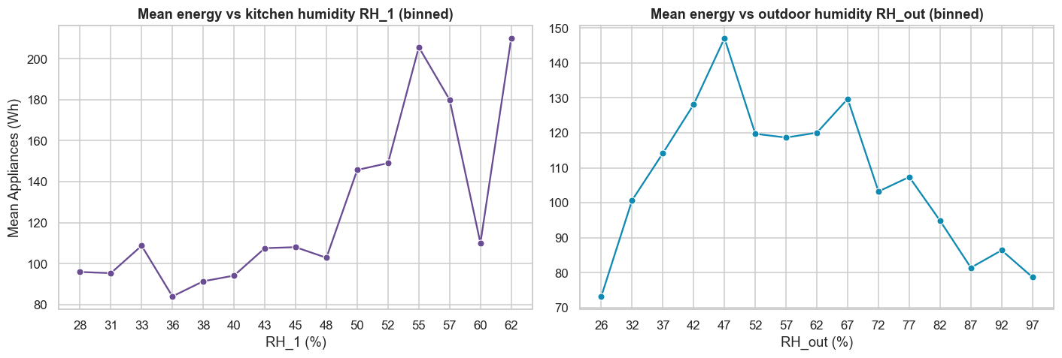
Mean energy across indoor (left) and outdoor (right) humidity bins.
Insight: humidity shows a mild, non-monotonic association with energy — a secondary HVAC signal.

4.5 Correlation structure & strongest linear drivers
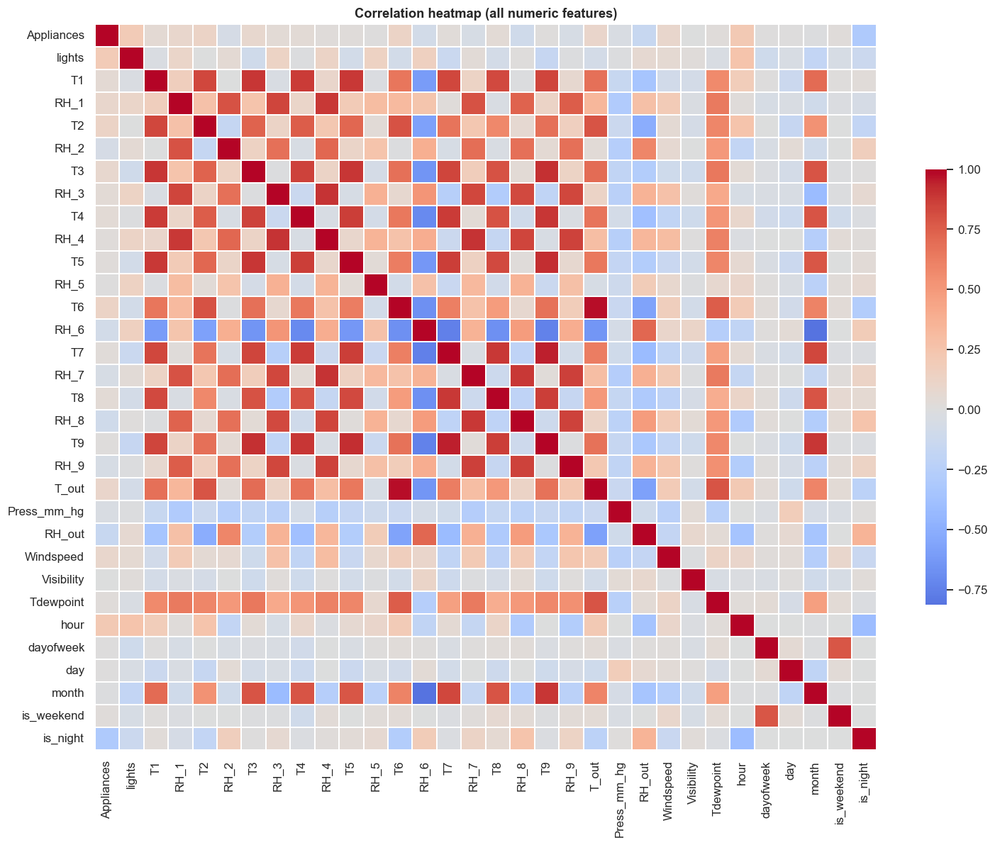
Correlation heatmap — room temperatures move together (shared building climate).
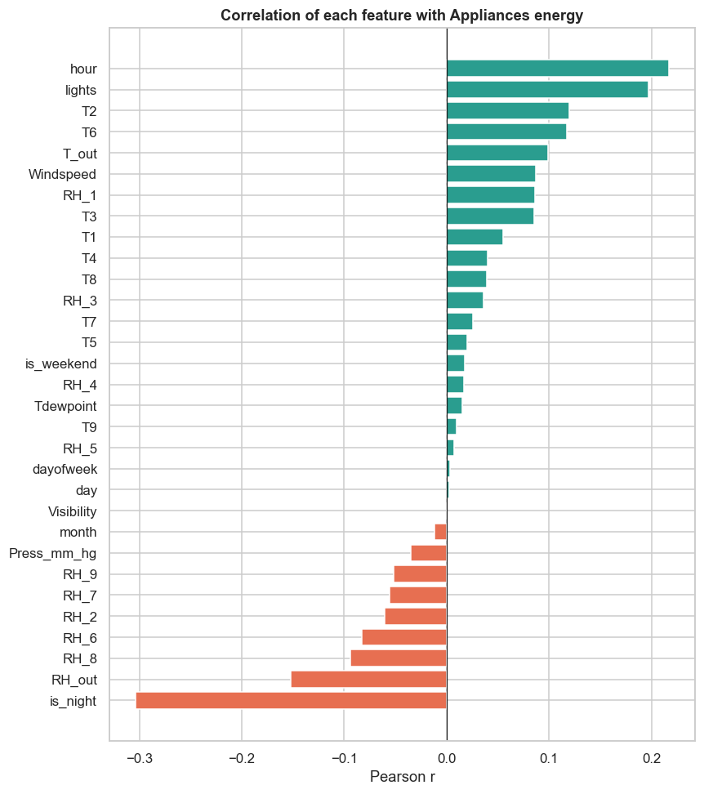
Each feature's linear correlation with appliance energy.
Insight: individual linear correlations with energy are modest, confirming that value comes from non-linear interactions and temporal context — not any single sensor.

4.6 Temporal trend & weekly seasonality
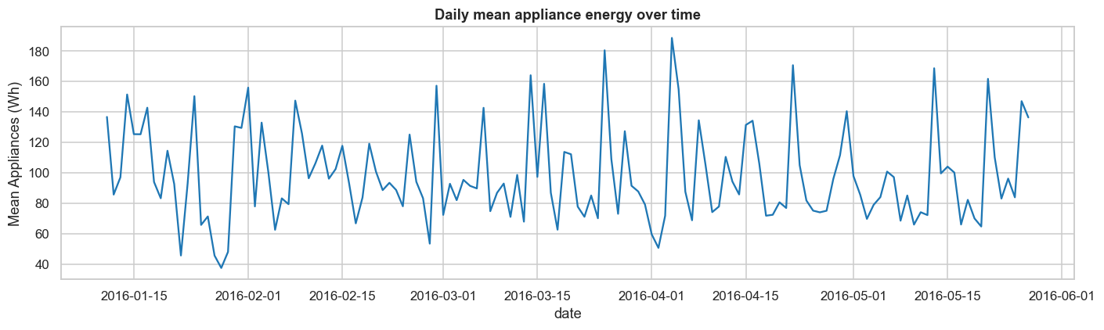
Daily mean energy across the recording period.
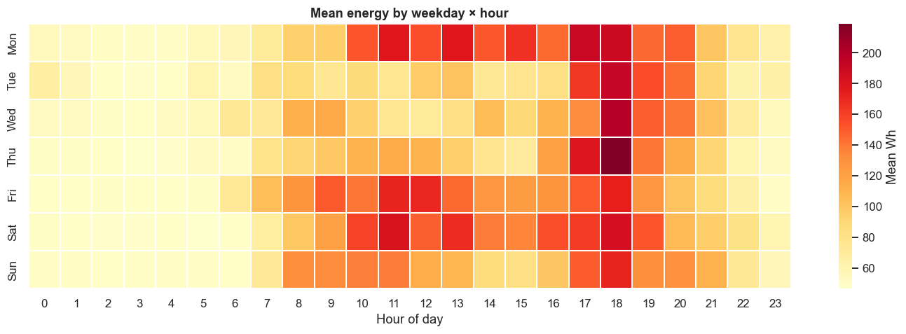
Mean energy by weekday × hour — the recurring evening hot-spot.
Insight: a strong, repeating daily pattern (hot evenings, cool nights) justifies the time-based and lag features used in modelling.

5. Data Cleaning & Feature Engineering

Cleaning
- Missing values: none — confirmed with an explicit audit, so no imputation needed.
- Outliers: ~11% of intervals exceed the IQR fence, but these are genuine demand peaks. We keep them (modelling log1p already compresses the tail) instead of winsorizing away the events the business cares about.
- Noise columns rv1/rv2 excluded; SHAP later confirms the model ignores them.

Engineered features
Feature | Why it matters
hour, is_weekend, is_night, month | Capture daily & weekly behaviour
hour_sin, hour_cos | Cyclical encoding so 23:00 and 00:00 are neighbours
indoor_temp_mean | Overall house warmth (rooms are correlated)
temp_diff (indoor − outdoor) | The key HVAC heating/cooling driver
lag_1 / lag_2 / lag_3 | Energy is strongly autocorrelated — recent past predicts next step
roll_mean_3/6/18, roll_std_6 | Short-to-medium consumption trend & volatility (30 min → 3 h)

Leakage-safe by construction: every lag/rolling feature uses .shift(1), so a row only sees the past. Combined with the chronological split and TimeSeriesSplit tuning, the evaluation reflects real forecasting performance.

6. Modelling & Comparison
Four models of increasing power, all predicting log1p(Appliances) and scored on the real Wh scale over the held-out future period. Random Forest and XGBoost were tuned with RandomizedSearchCV; LightGBM with Optuna (25 trials) — all over a TimeSeriesSplit.
Model | Test R² | RMSE | MAE | Role
Linear Regression | 0.40 | 70.1 | 28.1 | Interpretable baseline
Random Forest | 0.56 | 60.2 | 27.9 | Non-linear interactions
XGBoost | 0.56 | 60.1 | 23.6 | Strong gradient boosting
LightGBM | 0.57 | 59.3 | 23.7 | Best — fast & accurate
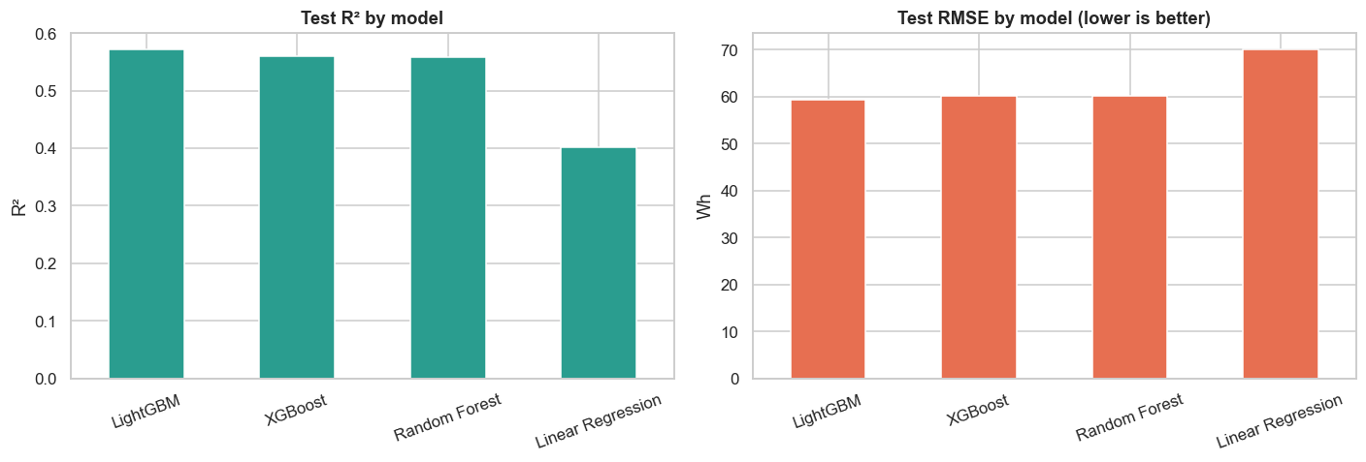
Test R² and RMSE by model — boosting beats the linear baseline by ~17 R² points.
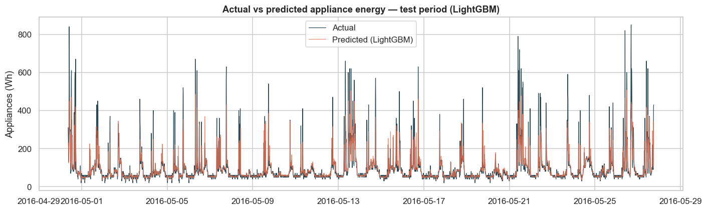
LightGBM predictions vs actual over the unseen test period — peaks and rhythm tracked well.

7. What Drives Energy — SHAP Explainability
SHAP decomposes each prediction into per-feature contributions, answering which variables matter and why a given prediction is high or low.
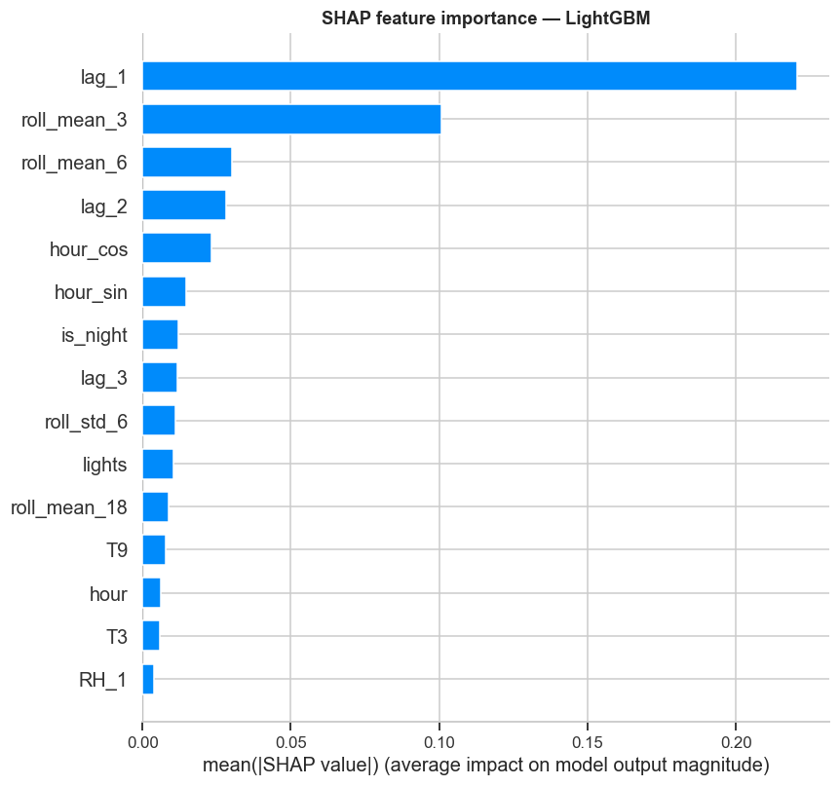
Mean |SHAP| — overall feature importance.
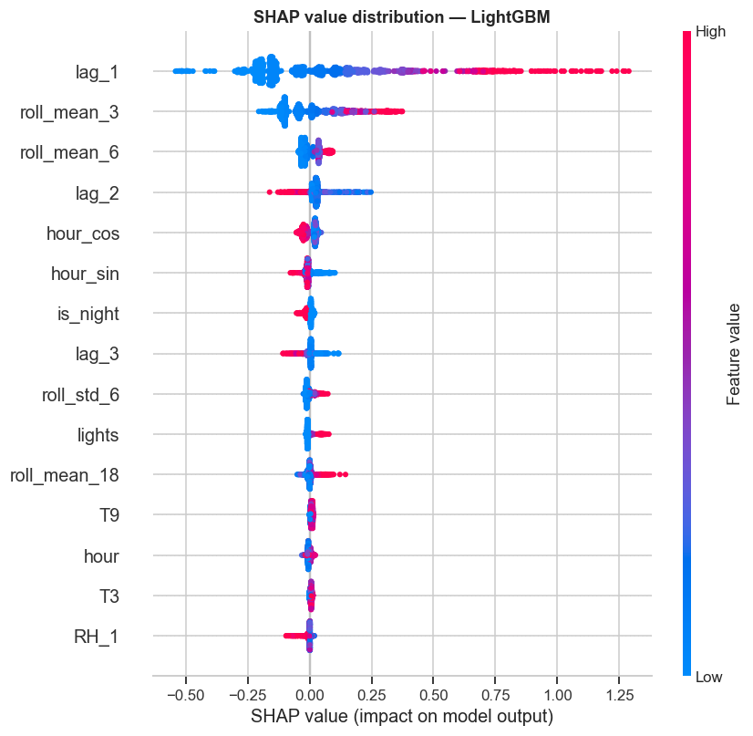
SHAP value distribution — direction & magnitude of each feature's effect.
Finding: time-of-day (hour_cos/hour_sin, is_night) and recent usage (lags/rolling means) dominate — this household's consumption is driven more by occupancy rhythm than by weather. Among environmental features, indoor temperatures and lighting carry the most signal. The random columns rv1/rv2 contribute essentially nothing, a healthy sign the model isn't overfitting noise.

8. Business Value & Recommendations

Actionable recommendations
- Load shifting: schedule deferrable appliances (dishwasher, washing machine, EV charging) into the 02:00–04:00 off-peak window — an estimated 5–15% cost saving with no change in usage.
- HVAC optimisation: temp_diff (indoor − outdoor) is a top environmental driver; pre-conditioning before the evening peak flattens the 17–20h load.
- Demand-peak forecasting: next-interval predictions let utilities and building managers anticipate evening peaks for better grid planning.
- Anomaly watch: flag intervals where actual ≫ predicted as possible faulty appliances or unexpected spikes.

Quantified value
Lever | Expected impact
Smart-home load shifting | 5–15% electricity-cost reduction
HVAC schedule optimisation | Lower evening peak demand & operating cost
Utility demand forecasting | Fewer overloads, better capacity planning
Residual anomaly alerts | Early detection of faulty appliances

9. Deliverables & Next Steps

What was produced
- Executed Jupyter notebook (Energy_Consumption_Prediction.ipynb) + HTML report — full narrative, all plots, models and SHAP.
- Reusable pipeline script (energy_pipeline.py).
- 12 figures, saved model (best_model.joblib), metrics table, and a dashboard-ready predictions CSV.
- Auto-generated recommendations (recommendations.md) and this report.

Future improvements
- Time-series models: benchmark Prophet / LSTM / GRU for multi-step forecasts.
- Weather-forecast integration: feed tomorrow's forecast to predict next-day demand.
- Anomaly detection: Isolation Forest / autoencoder on residuals for faulty-appliance alerts.
- Reinforcement learning: an agent that schedules appliances to minimise cost under a tariff.
- Power BI / Tableau dashboard built on predictions_for_dashboard.csv — forecast vs actual, peak hours, savings opportunities.

